Java and DSA –DAY 4

Move zeros to end:
1.Two Pointer Method:
import java.util.*;
class zero1{
public static void main(String[] args){
Scanner sc=new Scanner(System.in);
int n=sc.nextInt();
int[] a=new int[n];
for(int i=0;i<n;i++){
a[i]=sc.nextInt();
}
int left=0,right=n-1;
while(left<right){
while(left<right && a[left]!=0){
left++;
}
while(left<right && a[right]==0){
right--;
}
int temp=a[left];
a[left]=a[right];
a[right]=temp;
}
for(int i=0;i<n;i++){
System.out.print(a[i]+" ");
}
}
}

Output:
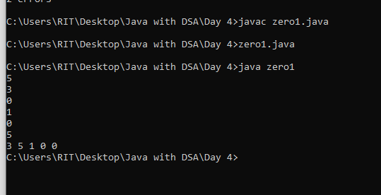

2. Without Two pointer:
import java.util.*;
class zero{
public static void main(String[] args){
Scanner sc=new Scanner(System.in);
int n=sc.nextInt();
int[] a=new int[n];
for(int i=0;i<n;i++){
a[i]=sc.nextInt();
}
int index=0;
for(int i=0;i<n;i++){
if(a[i]!=0){
a[index]=a[i];
index++;
}
}
for(int i=index;i<n;i++){
a[index]=0;
index++;
}
for(int i=0;i<n;i++){
System.out.print(a[i]+" ");
}
}
}

Output:
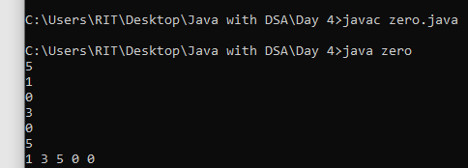

Maximum of sub array:
Brude force:
import java.util.*;
class sub{
public static void main(String[] args){
int[] arr={-2,1,-3,4,-1,2,5,4};
int max=0;
for(int i=0;i<arr.length;i++){
int sum=arr[i];
max=Math.max(max,sum);
for(int j=i+1;j<arr.length;j++){
sum+=arr[j];
max=Math.max(max,sum);
}
}
System.out.print("maximum: "+max);
}
}

Kedan’s Algorithm:
import java.util.*;
class sub1{
public static void main(String[] args){
int[] arr={-2,1,-3,4,-1,2,5,4};
int max=0;
int sum=0;
for(int i=0;i<arr.length;i++){
sum+=arr[i];
max=Math.max(max,sum);
if(sum<0){
sum=0;
}
}
System.out.print("maximum: "+max);
}
}
Output:
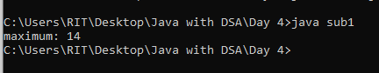

Sliding Window:
Brude force:
import java.util.*;
class slide{
public static void main(String[] args){
int[] arr={-2,1,-3,4,-1,2,5};
int max=0;
int n=arr.length;
int k=3;
for(int i=0;i<=n-k;i++){
int sum=0;
for(int j=i;j<i+k;j++){
sum+=arr[j];
}
max=Math.max(max,sum);
}
System.out.print("maximum: "+max);
}
}
Optimized:
import java.util.*;
class slide1{
public static void main(String[] args){
int[] arr={-2,1,-3,4,-1,2,5};
int n=arr.length;
int k=3;
int sum=0;
for(int i=0;i<k;i++){
sum+=arr[i];
}
int max=sum;
for(int j=k;j<n;j++){
sum=(sum-arr[j-k])+arr[j];
max=Math.max(max,sum);
}
System.out.print("maximum: "+max);
}
}
Output:
